Preliminary Report

1. In the Case Study although they target customers based on the age group (12-45) but I can’t make any insights out of it
2. A blue pie chart with a number of percentages

   Description automatically generatedROI can’t be figured based on the given data

Based on Insights some observations can be made

* Based on the above data TV sales Is negligible
* There are not many defined categories, so about 65% fall under 'others'
* A screenshot of a black screen

  Description automatically generated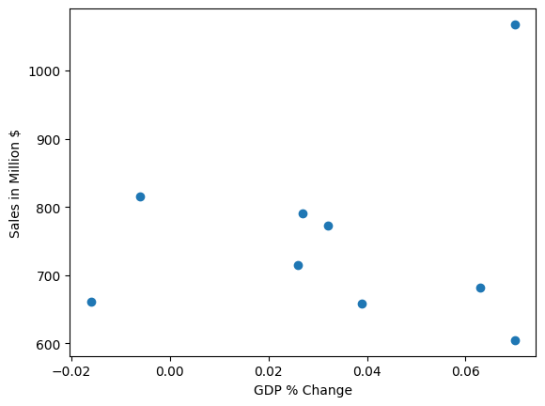A graph with blue and orange bars

  Description automatically generatedDigital is the most Important Channel
* Macro-economic Factors Doesn’t have an any considerable impact on sales based on the correlation between sales and (GDP, Inflation) because GDP has weak negative correlation(-0.22), whereas inflation has weak positive correlation(0.28)